**Lesson04 Azure Linux Lab Plan Service**

**Notes: -**

**1-we have .net core app that can hosted in both windows and LINUX O.S**

**(be sure when create app service that resource group belong to is support Linux O.S)**

**2-we crate Azure service plan with specify the O.S type and runtime stack (.Net Core 3.1)**

**3-in order to create multiple Azure web app service on the same Azure service plan , they must be on the same region**

**4-foreach Runtime stack it has its own Azure service plan**

**(we specify the Azure service Plan S1)**

**(make sure that resource group is central-us or support Linux Web App )**

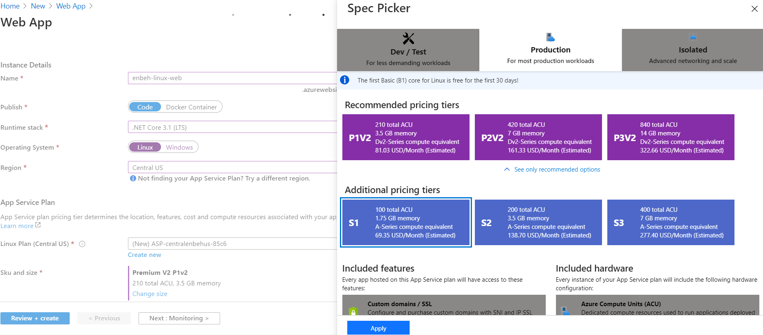

**5-on .Net Core click Publish > Azure App Service (Linux)**

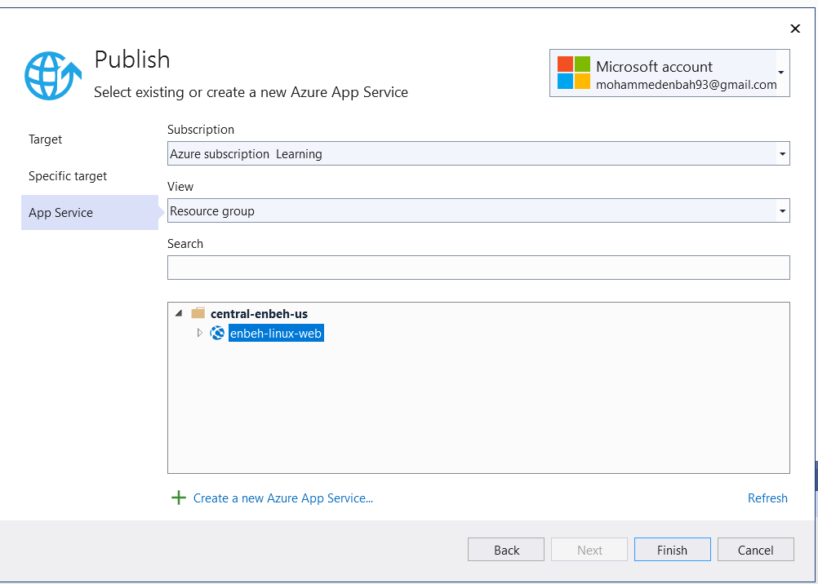

**(You will see that the web app is deployed)**



**6-you can see the CPU utilization and memory utilization etc.**